1) Connect and disconnect with login Access

* What happens when you login a non-existent users or username?
  + Provide Screenshot and What you understand, explain in short brief?

Ans= When I first boot up CentOS and log in using my primary account, everything runs smoothly. However, if we use a different, nonexistent user, then the user window works and sends us to the password window, but when we input the password, nothing happens. Therefore, you should make a new account from scratch if you need access to another account.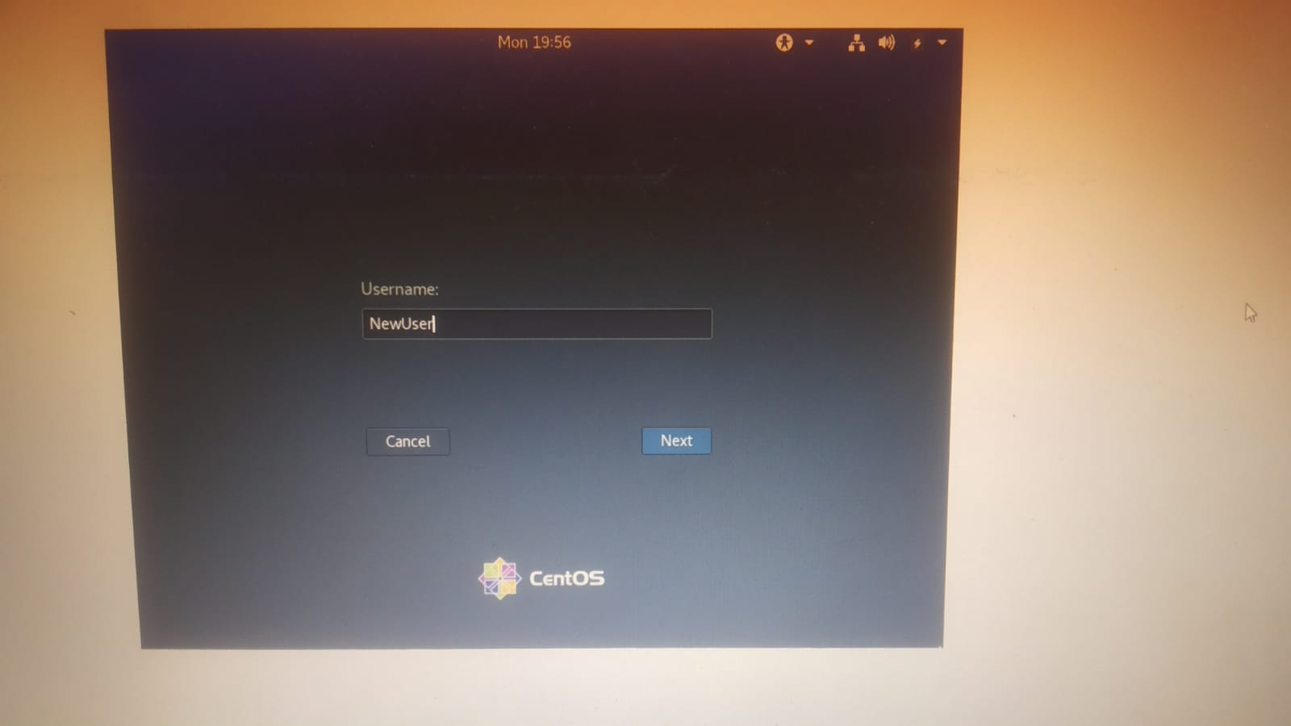

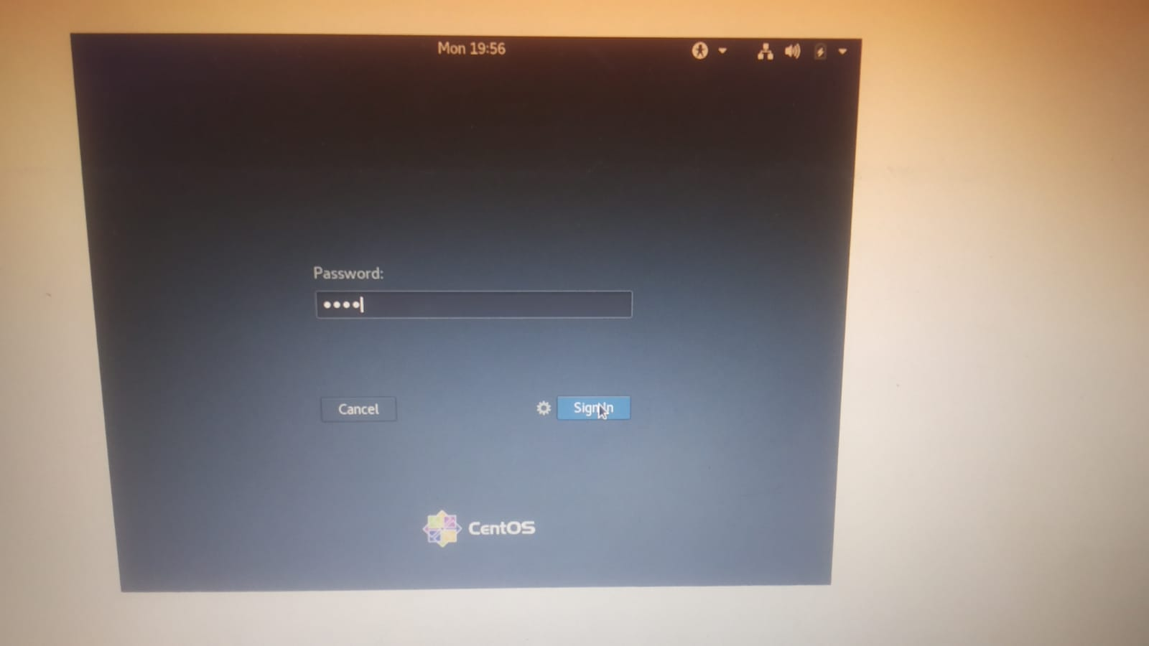

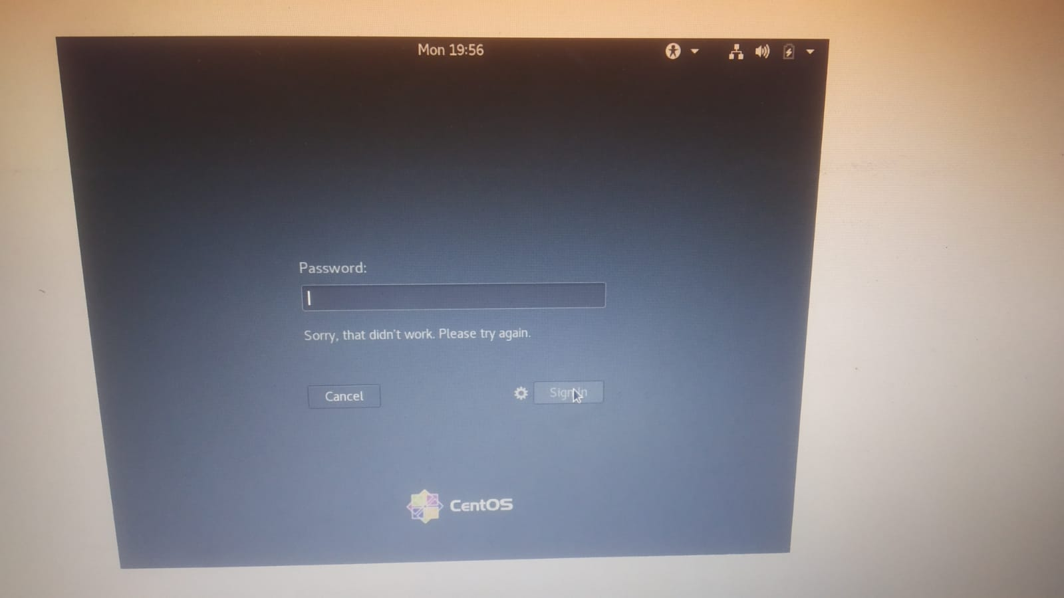

Working with Directories

* Enter the command **cd /** and then **ls** and then hit the **Enter** key
  + Take a screenshot and explain what output we got?
* Enter the command now **cd /home** and then hit **Enter** key
  + Do **ls,** provide screenshot and explain what is **/home** directory used for?
* Enter **cd ..** and hit **Enter** key [ *Note: here we have space after cd then use double dot*]
  + Check what happen and give screenshot?
* Now enter **cd /var/www/html** and then type **cd** and hit **Enter** key
  + Explain what happen and give screenshot?
* Now type **cd /root** and then hit **Enter** key
  + Do **ls,** check any output we have on screen if yes then take screenshot?

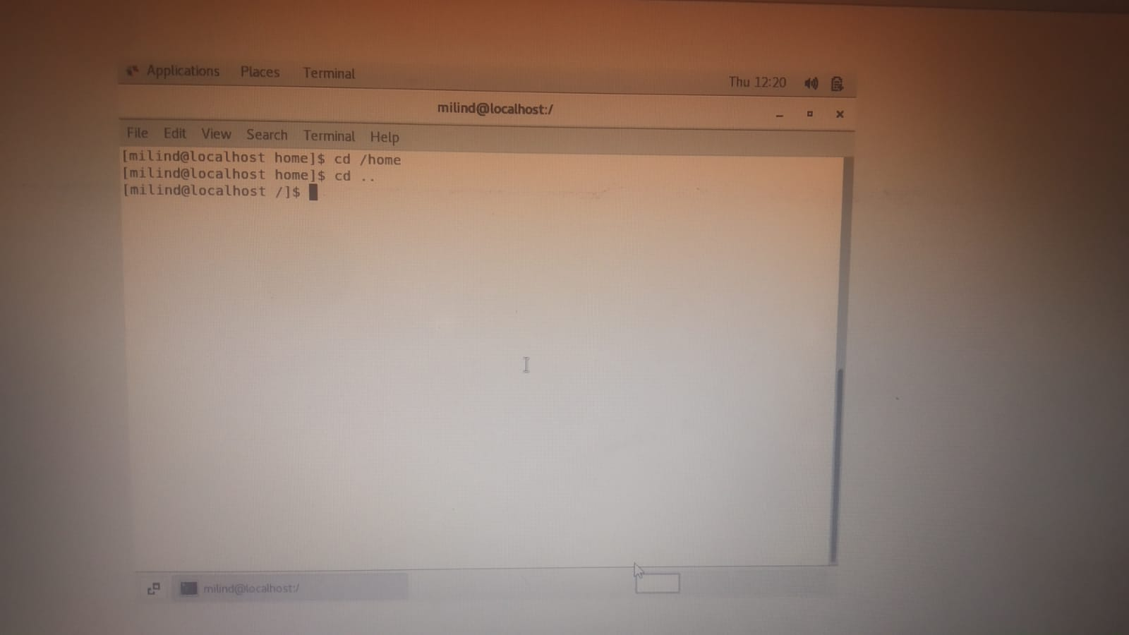

A home directory is a file system location that contains the files specific to a particular user.

A login directory is another name for a home directory.

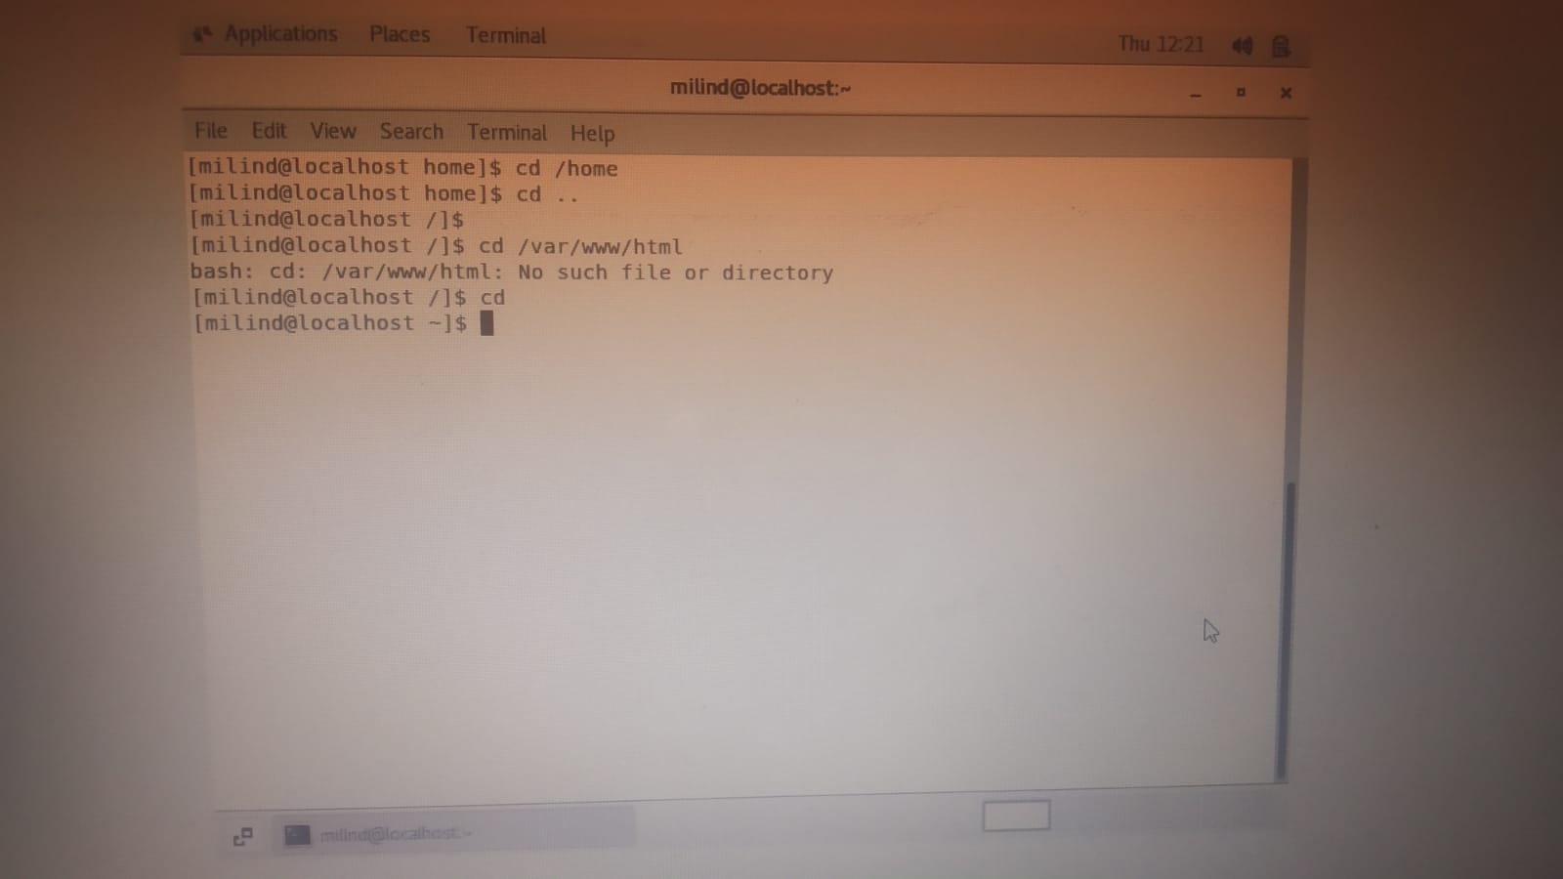

“Cd var/www/html”  is just the default root folder of the web server. You can change that to be whatever folder you want.

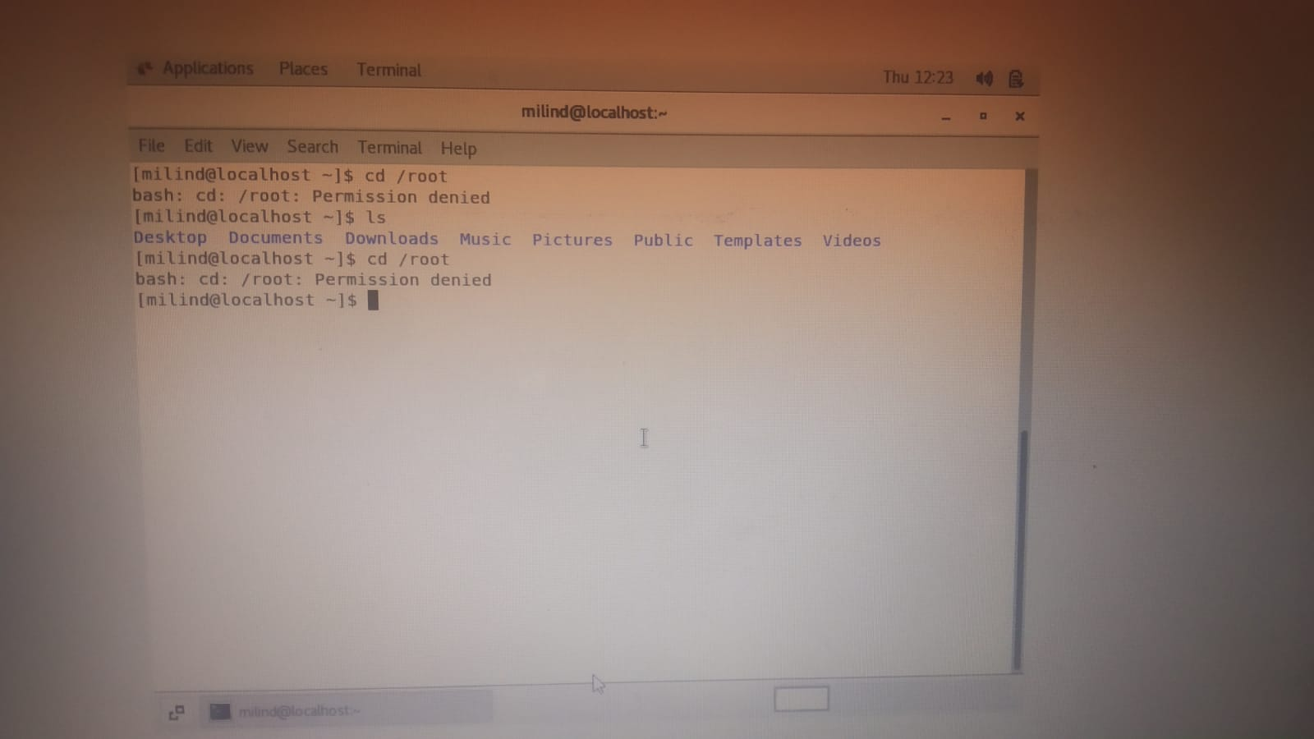

Working with File Listing

* Go to **cd /etc** and type **ls**
  + Take screenshot and explain what files you have seeing?
  + Take screenshot and explain what different output you found compare to previous command you used?
* Then type **ls -al** and hit **Enter** key
  + Take screenshot and explain what new file or directory you found?
* Then use **ls -i** and hit **Enter** key
  + Now see what different output its shows and take screenshot?
* Then use **ls –help** and see other options about **ls** command
  + Explore it and try with other attribute we can use with **ls** command

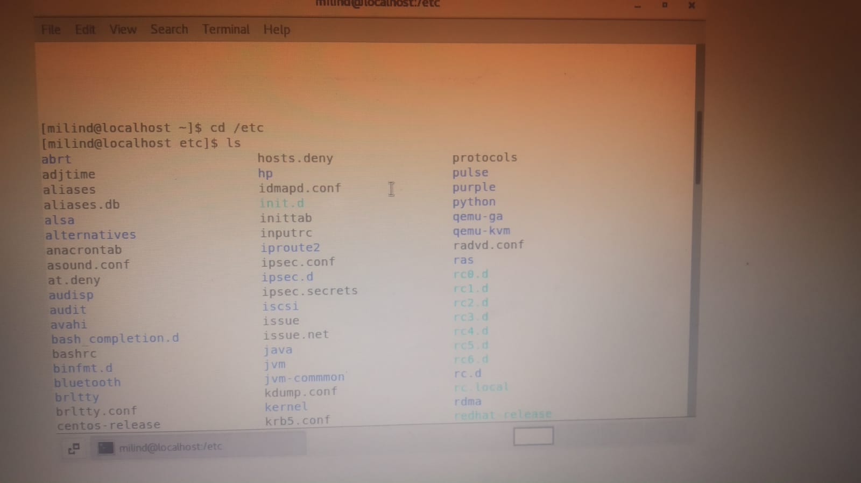

* For changing directory we use cd command and /etc is use in configuration files and directories which are located in system.

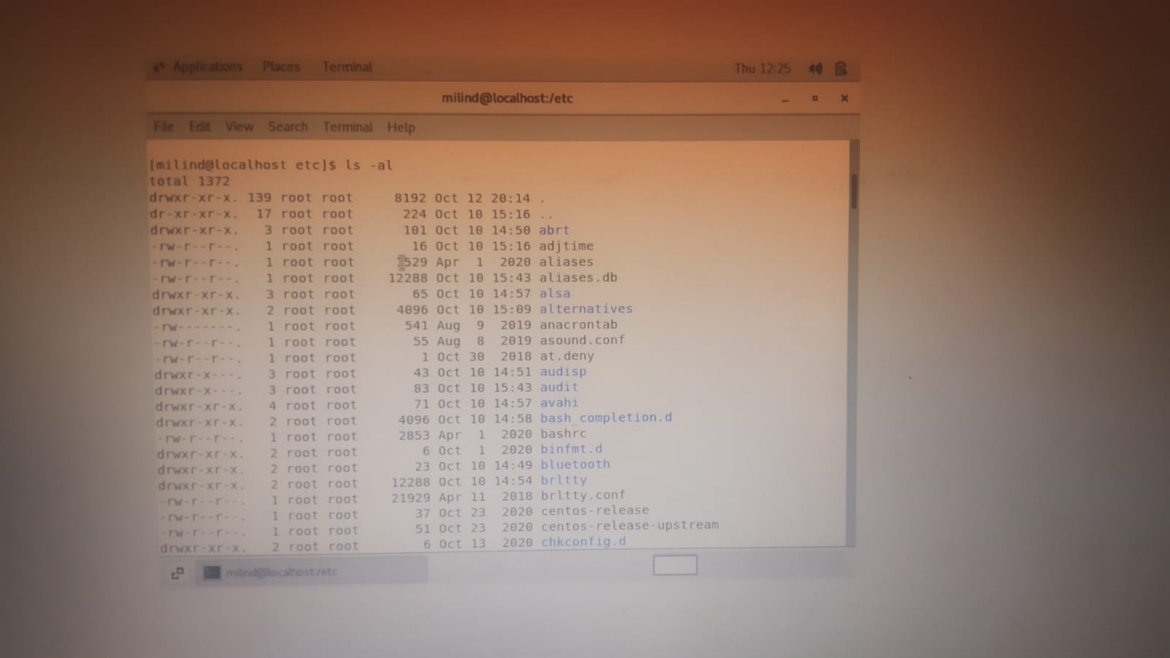

After inputting, the command's list of all files will appear, however this command differs in that it additionally displays the time and date's root value.

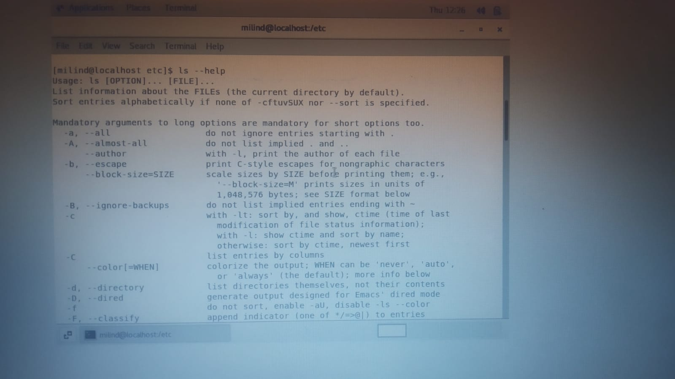

ls command lists information abouts files and directories

ls –help command is a list of command which we use in linux.

*Here we use* ***pwd, cd and ls*** *as combine task to understand where you working on terminal and how you can switch from one directory to another one.*

* Open terminal after restart the linux
  + Check which location you working, type **pwd** and take screenshot
* Now use **cd /var** and hit **Enter** key
  + Do **ls,** and see what output comes, give screenshot?
* Do explore other help options of each command to learn more other things we can do with these commands

